

12th “Pride and prejudice project”

Subject: English Teacher: Matías Donoso W
Student: _____________________________. Date: 13th, July
Ideal Score:44 points. | Real Score: | Mark:
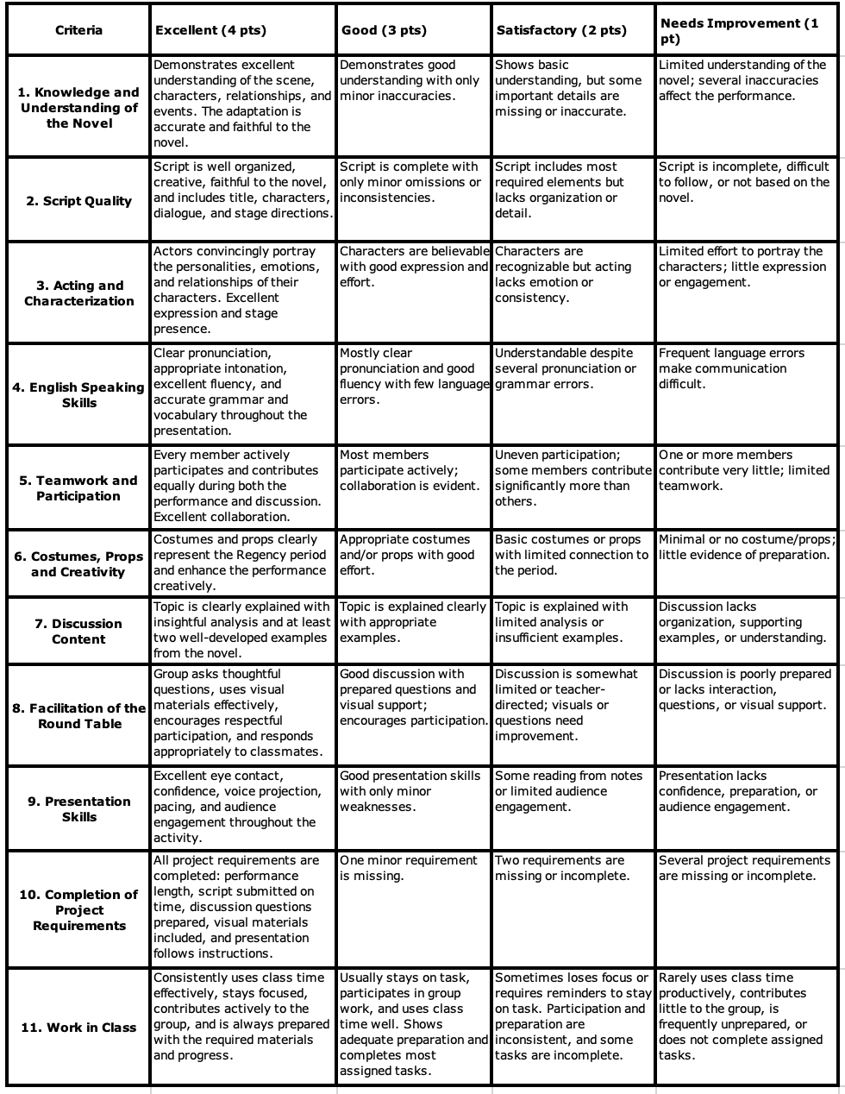



12th “Pride and prejudice project”

Subject: English Teacher: Matías Donoso W
Student: _____________________________. Date: 13th, July
Ideal Score:44 points. | Real Score: | Mark:

